**Poker APIs:**

*Run the following on the command terminal:*

**npm install** – installs needed packages

**npm run dev-start –** starts the api express app so we can simulate and make api requests.

Processes the submitted cards and returns all possible poker combinations. E.g. ( High Card, Pair, Two Pair, Three Of A Kind, Straight, Flush, Full House, Four Of A Kind, Straight Flush, Royal Flush) with rules as follows:

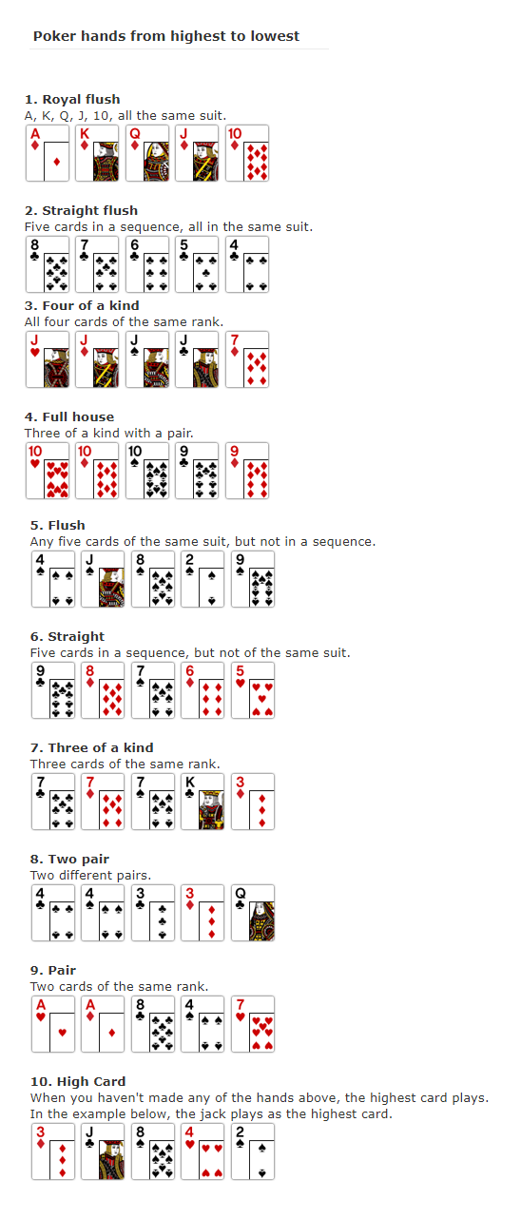

**POST:** localhost:3000/api/poker-demo

**Description**: Returns only the name of **ALL** hand combinations of the submitted cards. 1 player. Requires 5 cards.

**Sample request:**

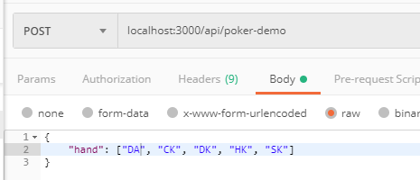

**Sample return:**

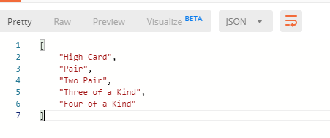

**POST:** localhost:3000/api/poker

**Description**: More detailed version of poker-demo api. Includes all the cards of the specified hands.

1 player. Requires 5-7 cards (use 7 for simulating the combinations that you can get on real poker game).

**Sample request:**

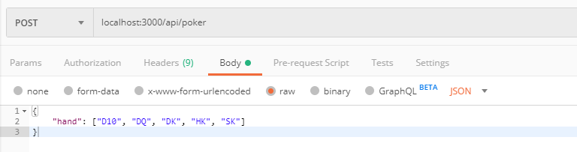

**Sample return:**

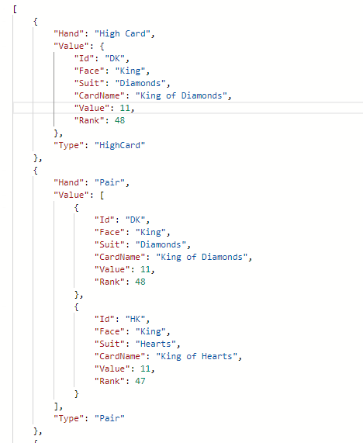

**POST:** localhost:3000/api/poker/win

**Description**: More detailed version of poker-demo api. Includes all the cards of the specified hands. Number of players not limited. Requires 5-7 cards (use 7 for simulating the combinations that you can get on real poker game). Also returns the player with the best hand.

**Sample request:**

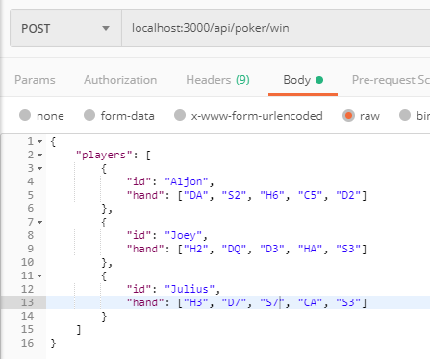

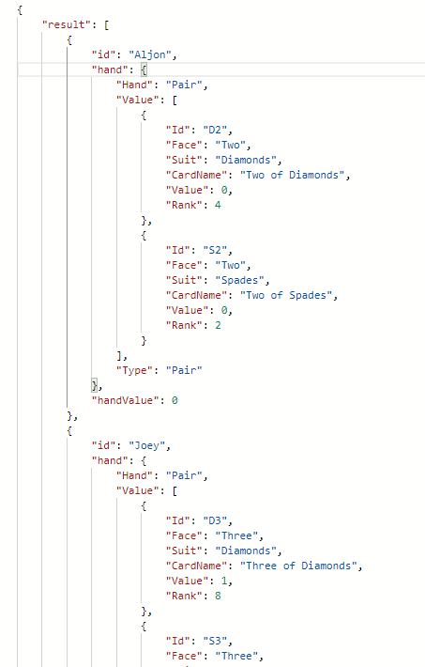**Sample return:**

